

**RECIPE ORGANIZED SYSTEM**

**Software Design Document**

– HoChiMinh, September 2022 –

**Table of Contents**

I. Overview 3

1. Code Packages 3

2. Database Schema 3

II. Code Designs 4

1. <Feature/Function Name1> 4

a. Class Diagram 4

b. Class Specifications 4

c. Sequence Diagram(s) 4

d. Database queries 5

2. <Feature/Function Name2> 5

III. Database Tables 5

1. <Table name 1> 5

2. <Table name 2…> 5

# I. Overview

## 1. Code Packages/Namespaces

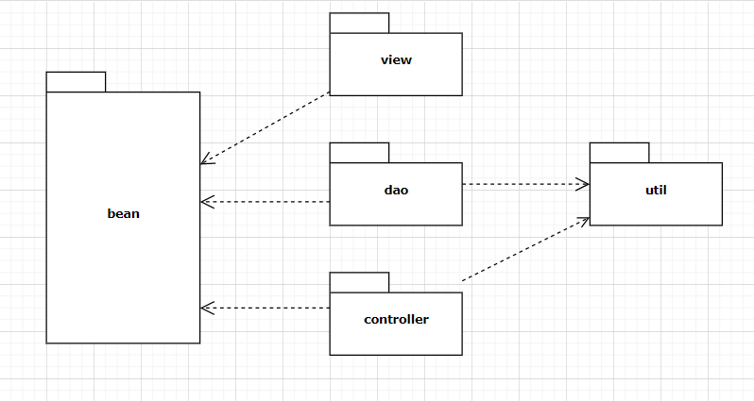

***Package descriptions & package class naming conventions***

|  |  |  |
| --- | --- | --- |
| **No** | **Package** | **Description** |
| 01 | bean | * Entity class * Classname + “DTO” (ex: ProductDTO.java) |
| 02 | view | * Is used for holds view for user and admin * lowerCase (ex:mainpage.jsp) |
| 03 | controller | * Is used for holds web controllers in MVC 2 models * Classname + “controller” (ex: HomeController.java) |
| 04 | dao | * Is used for holds class * Classname + “DAO” (ex: ProductDAO.java) |
| 05 | util | * The util methods should be moved to a helper or utility class or encapsulated within the class that uses them * Camelcase (ex: myToy.java) |

## 

## 2. Database Schema

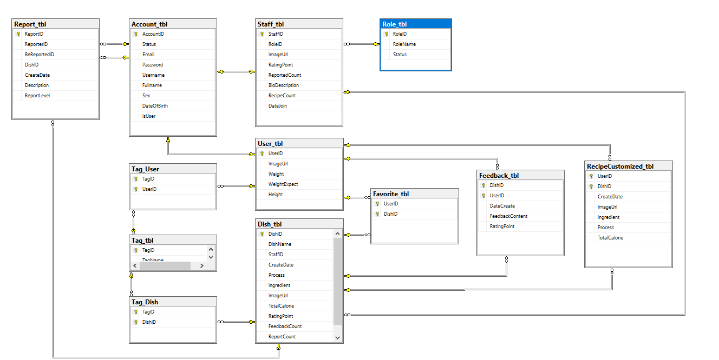

***Table descriptions & package class naming conventions are as below***

|  |  |  |
| --- | --- | --- |
| **No** | **Table** | **Description** |
| 1 | Account_tbl | - Primary keys: AccountID  - Contains information of accounts logged into the web |
| 2 | Staff_tbl | - Primary keys: StaffID  - Foreign keys: StaffID, RoleID  - Contains specifies information of staff accounts |
| 3 | User_tbl | - Primary keys: UserID  - Foreign keys: UserID  - Contains specifies information of user account |
| 4 | Dish_tbl | - Primary keys: DishID  - Foreign keys: StaffID,  - Contains information of Dish |
| 5 | Tag_tbl | - Primary keys: TagID  - Contains information of Tag |
| 6 | Feedback_tbl | - Primary keys: UserID, DishID  - Foreign keys: UserID, DishID  - Contains the content of the review that the user has rated for that dish |
| 7 | Favorite_tbl | - Primary keys: UserID, DishID  - Foreign keys: UserID, DishID  - Contain User favorite mark on that Dish |
| 8 | RecipeCustomized_tbl | - Primary keys: UserID, DishID  - Foreign keys: UserID,DishID  - Contains recipes of dishes that User wants to customize. |
| 9 | Report_tbl | - Primary keys: ReportID  - Foreign keys: ReporterID, BeReportedID, DishID  - Contains the report content that the user has reflected on that dish |
| 10 | Tag_User | - Primary keys: TagID, UserID  - Foreign keys: TagID, UserID  - Content tag user use to describe oneself |
| 11 | Tag_Dish | - Primary keys: TagID, UserID  - Foreign keys: TagID, DishID  - Content tag that cooker has marked to dish |
| 12 | Role_tbl | - Primary keys: RoleID  - Contains Role information of staff |

# II. Code Designs

# III. Database Tables

## 1. Account_tbl

- Contains information of accounts logged into the web

|  |  |  |  |  |  |  |  |
| --- | --- | --- | --- | --- | --- | --- | --- |
| **#** | **Field name** | **Type** | **Size** | **Unique** | **Not Null** | **PK/FK** | **Notes** |
| 1 | AccountID | nchar | 10 | x | x | PK |  |
| 2 | Status | bit | 1 |  | x |  |  |
| 3 | Email | nvarchar | max | x | x |  |  |
| 4 | Password | nvarchar | max |  | x |  |  |
| 5 | Username | nvarchar | max |  |  |  |  |
| 6 | Fullname | nvarchar | max |  |  |  |  |
| 7 | Sex | bit | 1 |  |  |  |  |
| 8 | DateOfBirth | date |  |  |  |  |  |
| 9 | IsUser | bit | 1 |  | x |  |  |

## 2. Staff_tbl

- Contains specifies information of staff accounts

|  |  |  |  |  |  |  |  |
| --- | --- | --- | --- | --- | --- | --- | --- |
| **#** | **Field name** | **Type** | **Size** | **Unique** | **Not Null** | **PK/FK** | **Notes** |
| 1 | StaffID | nchar | 10 | x | x | PK/FK |  |
| 2 | RoleID | nchar | 10 |  | x | FK |  |
| 3 | ImageUrl | nvarchar | max |  |  |  |  |
| 4 | RatingPoint | int |  |  |  |  |  |
| 5 | ReportedCount | int |  |  |  |  |  |
| 6 | BioDescription | nvarchar | max |  |  |  |  |
| 7 | RecipeCount | int |  |  |  |  |  |
| 8 | FollowerCount | int |  |  |  |  |  |
| 9 | DateJoin | date |  |  | x |  |  |

## 3. User_tbl

- Contains specifies information of user account

|  |  |  |  |  |  |  |  |
| --- | --- | --- | --- | --- | --- | --- | --- |
| **#** | **Field name** | **Type** | **Size** | **Unique** | **Not Null** | **PK/FK** | **Notes** |
| 1 | UserID | nchar | 10 | x | x | PK/FK |  |
| 2 | ImageUrl | nvarchar | max |  |  |  |  |
| 3 | Weight | int |  |  |  |  |  |
| 4 | WeightExpect | int |  |  |  |  |  |
| 5 | Height | int |  |  |  |  |  |

## 

## 4. Feedback_tbl

- Contains the content of the review that the user has rated for that dish

|  |  |  |  |  |  |  |  |
| --- | --- | --- | --- | --- | --- | --- | --- |
| **#** | **Field name** | **Type** | **Size** | **Unique** | **Not Null** | **PK/FK** | **Notes** |
| 1 | DishID | nchar | 10 |  | x | PK/FK |  |
| 2 | UserID | nchar | 10 |  | x | PK/FK |  |
| 3 | DateCreate | date |  |  | x |  |  |
| 4 | FeedbackContent | nvarchar | max |  |  |  |  |
| 5 | RatingPoint | int |  |  | x |  |  |

## 

## 

## 5. Dish_tbl

- Contains information of Dish

|  |  |  |  |  |  |  |  |
| --- | --- | --- | --- | --- | --- | --- | --- |
| **#** | **Field name** | **Type** | **Size** | **Unique** | **Not Null** | **PK/FK** | **Notes** |
| 1 | DishID | nchar | 10 | x | x | PK |  |
| 2 | DishName | nvarchar | max |  | x |  |  |
| 3 | StaffID | nchar | 10 |  | x | FK |  |
| 4 | CreateDate | date |  |  | x |  |  |
| 5 | Process | nvarchar | max |  |  |  |  |
| 6 | Ingredient | nvarchar | max |  |  |  |  |
| 7 | ImageUrl | nvarchar | max |  |  |  |  |
| 8 | TotalCalorie | int |  |  |  |  |  |
| 9 | RatingPoint | int |  |  |  |  |  |
| 10 | FeedbackCount | int |  |  |  |  |  |
| 11 | ReportCount | int |  |  |  |  |  |
| 12 | Status | nchar | 10 |  | x |  |  |

## 6. Tag_tbl

- Contains information of Tag

|  |  |  |  |  |  |  |  |
| --- | --- | --- | --- | --- | --- | --- | --- |
| **#** | **Field name** | **Type** | **Size** | **Unique** | **Not Null** | **PK/FK** | **Notes** |
| 1 | TagID | nchar | 10 | x | x | PK |  |
| 2 | TagName | nvarchar | max |  | x |  |  |

## 7. RecipeCustomize_tbl

- Contains recipes of dishes that User wants to customize.

|  |  |  |  |  |  |  |  |
| --- | --- | --- | --- | --- | --- | --- | --- |
| **#** | **Field name** | **Type** | **Size** | **Unique** | **Not Null** | **PK/FK** | **Notes** |
| 1 | UserID | nchar | 10 |  | x | PK/FK |  |
| 2 | DishID | nchar | 10 |  | x | PK/FK |  |
| 3 | CreateDate | date |  |  | x |  |  |
| 4 | ImageUrl | nvarchar | max |  |  |  |  |
| 5 | Process | nvarchar | max |  |  |  |  |
| 6 | Ingredient | nvarchar | max |  |  |  |  |
| 7 | TotalCalorie | int |  |  |  |  |  |

## 8. Report_tbl

- Contains the report content that the user has reflected on that dish

|  |  |  |  |  |  |  |  |
| --- | --- | --- | --- | --- | --- | --- | --- |
| **#** | **Field name** | **Type** | **Size** | **Unique** | **Not Null** | **PK/FK** | **Notes** |
| 1 | ReportID | nchar | 10 | x | x | PK |  |
| 2 | ReporterID | nchar | 10 |  | x | FK |  |
| 3 | BeReportedID | nchar | 10 |  | x | FK |  |
| 4 | DishID | nchar | 10 |  | x | FK |  |
| 5 | CreateDate | date |  |  | x |  |  |
| 6 | Description | nvarchar | max |  |  |  |  |
| 7 | ReportLevel | int |  |  | x |  |  |

## 9. Favorite_tbl

- Contain User favorite mark on that Dish

|  |  |  |  |  |  |  |  |
| --- | --- | --- | --- | --- | --- | --- | --- |
| **#** | **Field name** | **Type** | **Size** | **Unique** | **Not Null** | **PK/FK** | **Notes** |
| 1 | UserID | nchar | 10 |  | x | PK/FK |  |
| 2 | DishID | nchar | 10 |  | x | PK/Fk |  |

## 10. Tag_User

- Content tag user use to describe oneself

|  |  |  |  |  |  |  |  |
| --- | --- | --- | --- | --- | --- | --- | --- |
| **#** | **Field name** | **Type** | **Size** | **Unique** | **Not Null** | **PK/FK** | **Notes** |
| 1 | TagID | nchar | 10 |  | x | PK/FK |  |
| 2 | UserID | nchar | 10 |  | x | PK/FK |  |

## 11. Tag_Dish

- Content tag that cooker has marked to dish

|  |  |  |  |  |  |  |  |
| --- | --- | --- | --- | --- | --- | --- | --- |
| **#** | **Field name** | **Type** | **Size** | **Unique** | **Not Null** | **PK/FK** | **Notes** |
| 1 | TagID | nchar | 10 |  | x | PK/FK |  |
| 2 | DishID | nchar | 10 |  | x | PK/FK |  |

## 12. Role_tbl

- Contains Role information of staff

|  |  |  |  |  |  |  |  |
| --- | --- | --- | --- | --- | --- | --- | --- |
| **#** | **Field name** | **Type** | **Size** | **Unique** | **Not Null** | **PK/FK** | **Notes** |
| 1 | RoleID | nchar | 10 | x | x | PK |  |
| 2 | RoleName | nchar | 10 |  | x |  |  |
| 3 | Status | bit |  |  | x |  |  |